

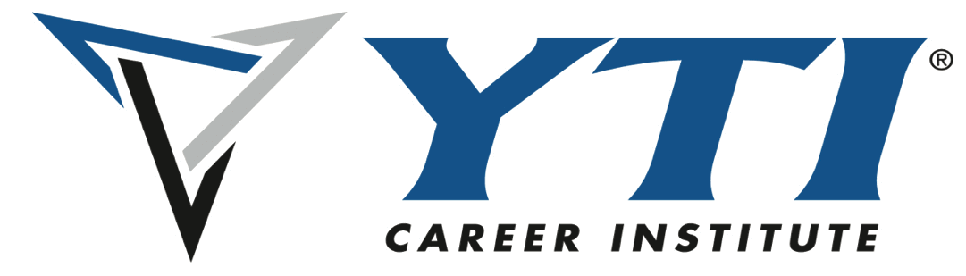

**For Immediate Release:**

**Contact: Desiree Morris**

**desiree.morris@yti.edu**

**717.654.1793**

**Exciting Opportunity for Porter and Chester Institute Dental Assisting Graduates to Advance Their Credentials**

**April 14th 2024-** We’re thrilled to share exciting news for graduates of the Dental Assisting program at Porter and Chester Institute (PCI)!

Earlier this year, our sister school, YTI Career Institute, was approached by the Dental Assisting National Board (DANB) to participate in a groundbreaking research study focused on the General Chairside (GC) Assisting exam. This unique opportunity was extended to dental assisting programs that are not currently accredited by the Commission on Dental Accreditation (CODA), offering a new pathway for graduates to advance their professional credentials.

Thanks to the initiative and leadership of Emily Yinger, Program Director of Dental Assisting & Expanded Functions Dental Assisting at YTI, the application was submitted and successfully approved. Recognizing the value of this opportunity, Emily inquired whether PCI campuses might also be eligible. In response, DANB provided applications for all seven PCI campuses. “We are proud to announce that all seven PCI campuses have officially been accepted into the study,” said Emily Yinger, Program Director of Dental Assisting & Expanded Functions Dental Assisting at YTI Career Institute.

This special study opens the door for eligible PCI Dental Assisting graduates to participate in a streamlined path toward earning certification by taking the General Chairside (GC) exam.

For more information about eligibility or how to apply, graduates are encouraged to contact their campus’s Dental Assisting Program Director or administrator.

**About Porter and Chester Institute:** Porter and Chester Institute (PCI), a private, post-secondary technical institution with seven campuses throughout Connecticut and Massachusetts, featuring twelve different career programs, supports committed students in achieving the technical and professional skills essential for their chosen career through industry- modeled, student-centered education and training. For more information, please visit PCI at [www.PorterChester.edu](http://www.PorterChester.edu/) or call (800) 870-6789**.**

**About YTI Career Institute:** YTI is a private, post-secondary technical institution of higher education serving south-central Pennsylvania at the York, Lancaster, and Altoona campuses. YTI Career Institute offers career training in the [computer](https://yti.edu/programs/computer-programs), [culinary arts](https://yti.edu/paschoolofculinaryarts), [healthcare](https://yti.edu/programs/medical-programs) and skilled [trades](http://trades) fields. For more information, visit [www.yti.edu](http://www.yti.edu).